Report 1: Biomedical Waste due to Covid – 19

Name: Naman Garg  
Roll Number: B032  
Class: B. Tech CS (Div. B) Sem 5  
  
Garbage contaminated with bodily fluids or other infectious materials is becoming a bigger concern for hospitals as they brace for a surge in patients sick with COVID-19 in the US. Patients and health care workers are quickly going through medical supplies and disposable personal protective equipment, like masks. Eventually all that used gear piles up as medical waste that needs to be safely discarded.

In Wuhan, where the novel coronavirus first emerged, officials didn’t just need to build new hospitals for the influx of patients; they had to construct a new medical waste plant and deploy 46 mobile waste treatment facilities too. Hospitals there generated six times as much medical waste at the peak of the outbreak as they did before the crisis began. The daily output of medical waste reached 240 metric tons, about the weight of an adult blue whale.

HOSPITALS GENERATED 6 TIMES AS MUCH MEDICAL WASTE

There’s already been an uptick of garbage from personal protective equipment in the US, according to medical waste company Stericycle, which handled 1.8 billion pounds of medical waste globally in 2018. And some things that aren’t usually considered medical waste, like food, now need to be handled more carefully after coming in contact with a COVID-19 patient. Stericycle didn’t provide numbers for how much of an increase it’s seeing so far, adding that it believes it has the capacity to handle the swell and may add shifts to the company’s 50 treatment centers in the US if necessary. Additionally, the drop in elective surgeries might offset some of the rise in waste we’re seeing from the pandemic, a spokesperson for Stericycle tells The Verge.

“It’s a rapidly changing environment right now and forecasting volumes is challenging,” Stericycle Vice President of Corporate Communications Jennifer Koenig wrote in an email to The Verge. “We are closely monitoring the situation with all relevant agencies to determine next steps.”

“IT’S A RAPIDLY CHANGING ENVIRONMENT”

The CDC says that medical waste from COVID-19 can be treated the same way as regular medical waste. Regulations on how to treat that waste vary by location and can be governed by state health and environmental departments, as well as by the Occupational Safety and Health Administration and the Department of Transportation. Generally, to make sure contaminated trash from health care facilities doesn’t pose any harm to the public before going to a landfill, it’s typically burned, sterilized with steam, or chemically disinfected.

There’s more to worry about than waste from medical centers. The disease is spread out beyond hospitals. Some people who have minor symptoms are recovering at home. Others who are asymptomatic might not know that the trash they’re throwing out could be contaminated. That means people may be generating plenty of virus-laden trash. That’s worrying for sanitation workers, as the virus can persist for up to a day on cardboard and for longer on metal and plastic, according to one study of the virus in lab conditions.

But if garbage is properly bagged instead of kept loose and workers are wearing personal protective equipment, especially gloves, then there shouldn’t be a risk of catching the virus, David Biderman, CEO of the Solid Waste Association of North America, tells The Verge. Practicing social distancing while on the job, including maintaining appropriate distances from people, may also help reduce sanitation workers’ risks, says Elise Paeffgen, a partner with the firm Alston & Bird who works on medical waste issues.

PEOPLE HANDLING HEALTH CARE WASTE SHOULD WEAR APPROPRIATE GEAR

People handling health care waste in particular should wear appropriate gear, including boots, aprons, long-sleeved gowns, thick gloves, masks, and goggles or face shields, according to recommendations from the World Health Organization. Luckily, protective efforts so far seem to have paid off. “There is no evidence that direct, unprotected human contact during the handling of health care waste has resulted in the transmission of the COVID-19 virus,” according to a March 19th technical brief from the WHO. As the pandemic grows, so will the waste, and keeping that garbage safe and contained will continue to be a challenge for communities until the crisis is over.

BOIMEDICAL WASTE BREAKDOWN::

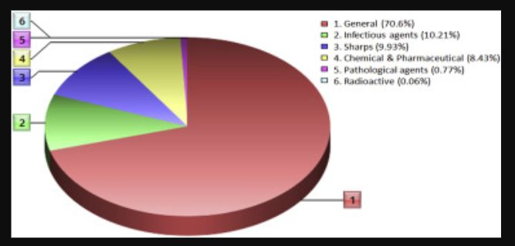

STANDARDS FOR SEGRIGATION IN INDIA::

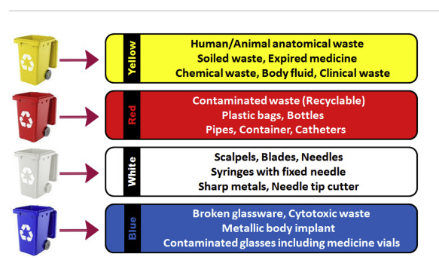

Climate change events in 219-2020

1. Second warmest year, warmest month, and warmest decade on record globally

The final numbers will not be in until January 15, but 2019 is highly likely to wind up as the second warmest year on record globally—a greater than 99% chance, according to Berkeley Earth. A December 3 report from the World Meteorological Organization (WMO) found that January – October temperatures were 1.1°C above Earth’s pre-industrial average temperatures in the 1800s; the 2015 Paris Climate Accord’s goal was to limit global warming to no more than 2°C above pre-industrial temperatures, so we are more than half way there. Under current policies, we are on track to see 3°C of warming by 2100, according to the Climate Action Tracker.

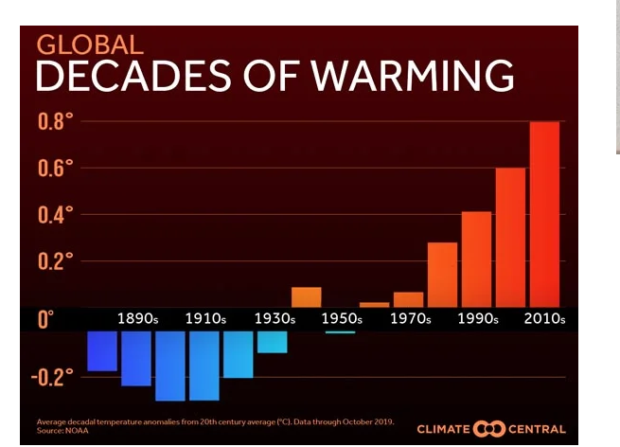

The year brought two extraordinary heat waves to Europe. The June 26 – 30, 2019 heat wave was the greatest June heat wave in European history. Hundreds of stations with a long-term period of record (POR) set their all-time June maximum temperature records, and all-time heat records for any month were set in two nations—France, and Andorra. The astonishing 46.0°C (114.8°F) at Verargues in southern France on June 28 destroyed the previous all-time national heat record by 1.9°C (3.4°F). In all, a remarkable 12 stations beat or tied the former all-time national French heat record on June 28. All-time heat records fell at 84 stations with long-term PORs in eleven nations—Germany, France, Switzerland, Austria, Poland, Italy, Liechtenstein, Andorra, Spain, Denmark, and the Czech Republic.

2. India’s wettest monsoon in 25 years replenishes reservoirs but kills 1750 people

Despite an unusually late start, the June – September monsoon period in India featured rains 10% above average, making it the most bountiful monsoon of the past 25 years, said the India Meteorological Department (IMD). The heavy rains were a huge blessing for a nation that is suffering critical water shortages. As I wrote in June 2019, over 12% of India’s population--163 million people of 1.3 billion--live under “Day Zero” conditions, with no access to clean water near their home. That is the most of any country in the world. “Day Zero” is expected to arrive for millions more in India by 2020, when groundwater supplies are predicted to run out for 100 million people in the northern half of India, according to a startling report released in 2018 by Niti Ayog, India’s federal think tank. However, the bountiful rains of the 2019 monsoon season have replenished reservoirs and ground water supplies, and may push “Day Zero” back for many.

Unfortunately, the heavy monsoon rains also brought disastrous flooding to India, leading to the deaths of at least 1750 people. This toll made the 2019 monsoon in India Earth’s deadliest weather-related disaster of 2019. According to statistics from EM-DAT, the international disaster database, India has had six deadlier monsoon seasons since 1960. The deadliest year was 2013, when 6054 people perished from summer monsoon flooding in India. The $10 billion in damage from the 2019 floods ranks as the third most expensive flood in India's history, behind the $17.6 billion in damage from the 2014 floods and the $12.6 billion in damage from the 1993 floods, according to EM-DAT.

The intense monsoon rains of 2019 were due, in large part, to warm sea surface temperatures (SSTs) across the Arabian Sea boosted by the strongest positive mode of the Indian Ocean Dipole (IOD) [in 60 years](https://www.severe-weather.eu/news/unusually-strong-indian-ocean-dipole-australia-europe-fa/). The IOD is an irregular natural oscillation of SSTs in which the western Indian Ocean becomes alternately warmer and then colder than the eastern part of the ocean. There is no long-term trend in the IOD, and it is [uncertain](https://weather.com/en-IN/india/monsoon/news/2019-09-16-2019-to-be-one-of-strongest-iod-years-on-record-expert) how climate change may affect it. The unusual IOD in 2019 led to the [most active tropical cyclone season in the Arabian Sea](https://blogs.scientificamerican.com/eye-of-the-storm/tropical-cyclone-kyarr-150-mph-winds-arabian-seas-2nd-strongest-storm-on-record/) on record.

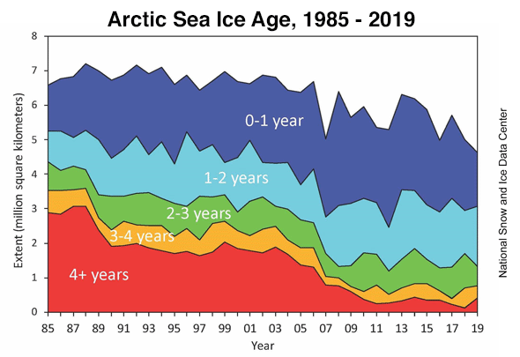

Arctic sea ice age between 1985 – 2019 from satellite measurements. Old, thick ice has become increasingly rare. Credit: [National Snow and Ice Data Center](http://nsidc.org/arcticseaicenews/files/1999/11/Figure5-1.png)

3. Near-record melting of Arctic sea ice

The Arctic experienced its second warmest year on record in 2019, according to NOAA’s [2019 Arctic Report Card](https://arctic.noaa.gov/Portals/7/ArcticReportCard/Documents/ArcticReportCard_full_report2019.pdf). The near-record warmth led to Arctic sea ice extent at the end of summer 2019 being tied for second-lowest since satellite observations began in 1979; only 2012 had a lower extent. The 13 lowest sea ice extents in the satellite record have all occurred in the last 13 years: 2007 - 2019.

At the beginning of the melt season, in March 2019, the Arctic had a near-record low extent of thick ice more than four years old: 1.2%. This is far lower than the 33% coverage of thick ice in 1985. Sea ice cover has transformed from a strong, thick ice mass in the 1980s to a younger, thinner ice mass in recent years. First-year ice is more vulnerable to melting out in summer, thereby increasing the likelihood of lower minimum ice extents. On the positive side, the total volume of Arctic sea ice in 2019 was slightly above the 2011 – 2019 average, thanks to some thicker-than-average sea ice in the central Arctic.

A [study](https://scripps.ucsd.edu/news/research-highlight-loss-arctics-reflective-sea-ice-will-advance-global-warming-25-years) published in Geophysical Research Letters in June 2019 described the serious consequences of losing the Arctic’s reflective summer sea ice, which reflects incoming sunlight back to space during the long summer days of midnight sun. With the ice gone, the sun’s energy will instead be absorbed by the ocean. Losing the ice will be equivalent of adding 25 years’ worth of greenhouse gas emissions at the current rate humans are burning fossil fuels, the study said.

The odds of seeing an ice-free Arctic Ocean in summer will rise to about 50% by the late 2030s under the business-as-usual emissions path we are currently on, according to [Jahn (2018)](https://www.nature.com/articles/s41558-018-0127-8) (and nicely [summarized by Carbon Brief](https://interactive.carbonbrief.org/when-will-the-arctic-see-its-first-ice-free-summer/?utm_campaign=Carbon%20Brief%20Daily%20Briefing&utm_medium=email&utm_source=Revue%20newsletter).) Limiting global warming to 2°C would delay this occurrence by about 8 years, the study said.

4. Monthly methane levels measured at the [Barrow Atmospheric Baseline Observatory](https://www.esrl.noaa.gov/gmd/dv/iadv/graph.php?code=BRW&program=ccgg&type=ts) in northern Alaska from 1988 – 2019. Methane peaked at 1989 ppb in September 2019, its highest level on record. Credit: [NOAA/ESRL](https://www.esrl.noaa.gov/gmd/dv/iadv/graph.php?code=BRW&program=ccgg&type=ts)

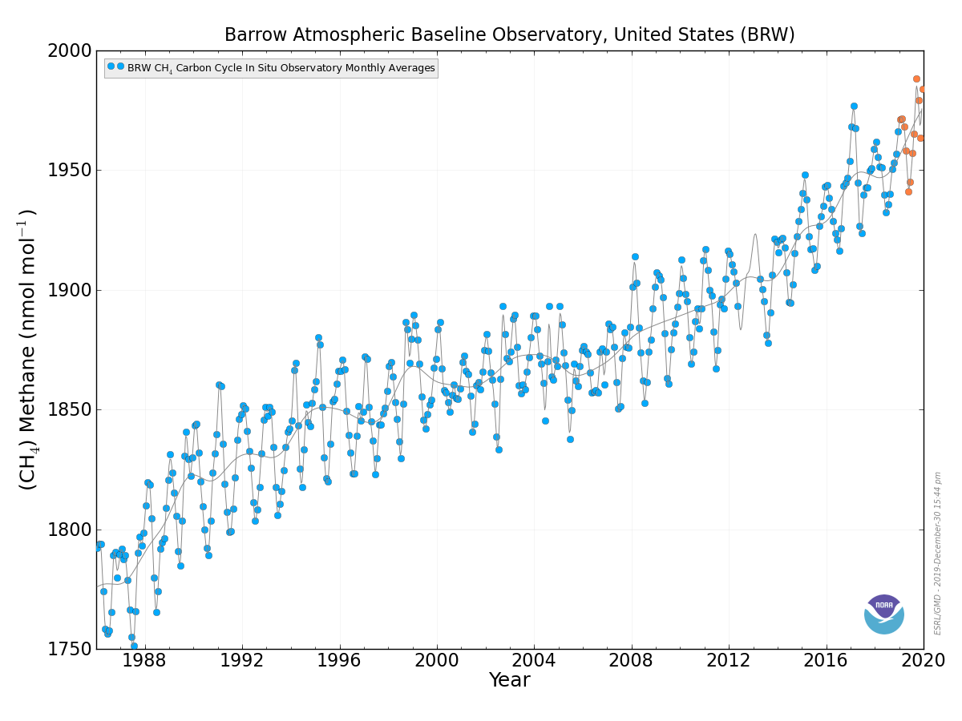

4. The long-feared permafrost carbon bomb may be exploding, says NOAA

NOAA’s [2019 Arctic Report Card](https://arctic.noaa.gov/Portals/7/ArcticReportCard/Documents/ArcticReportCard_full_report2019.pdf) also announced that the long-feared acceleration of global warming due to carbon stored in permafrost (as carbon dioxide and methane) may have begun, saying, “the accelerating feedback from changing permafrost ecosystems to climate change may already be underway.” Permafrost holds more than double the amount of carbon that is currently in the atmosphere in the form of heat-trapping gases like CO2 and methane. Methane levels at the Barrow Atmospheric Baseline Observatory in northern Alaska [peaked](https://www.esrl.noaa.gov/gmd/dv/iadv/graph.php?code=BRW&program=ccgg&type=ts) at their highest level on record in September 2019: 1989 ppb.

The estimated annual release rate in 2019 of 0.3 – 0.6 gigatons of carbon from permafrost is approximately 3 – 6% of the amount of carbon released into the air each year by human combustion of fossil fuels, according to the [Global Carbon Project](https://www.globalcarbonproject.org/carbonbudget/index.htm). “We think that should be two to three times bigger by the end of the century based on the kind of forecasting we’ve done,” [said](https://www.vox.com/energy-and-environment/2019/12/12/21011445/permafrost-melting-arctic-report-card-noaa) ecologist Ted Schuur, author of the Arctic Report Card’s section on permafrost.

Figure 5. Satellite-derived surface melt area as a percentage of the Greenland ice sheet area during 2019 (solid red) and record melt year of 2012 (solid purple), in addition to the 1981-2010 median (dashed blue) and interdecile and interquartile ranges (shaded). (b) Summer 2019 melt anomaly (in number of melting days) with respect to the 1981-2010 period, estimated from space-borne passive microwave observations. Credit: [NOAA 2019 Arctic Report Card](https://arctic.noaa.gov/Portals/7/ArcticReportCard/Documents/ArcticReportCard_full_report2019.pdf)

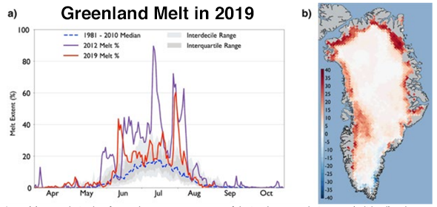

5. Near-record melting of the Greenland ice sheet contributes 20% of global sea level rise

The near-record warmth in the Arctic in 2019 led to the extent and magnitude of ice loss on the Greenland Ice Sheet from the fall of 2018 through the end of 2019 being close to that of Greenland’s previous record year for ice loss, 2012, said the 2019 Arctic Report Card. The report said that melting of ice from Greenland in 2019 contributed 0.7 mm/year of sea level rise to the world’s oceans--about 20% of the [current 3.3 mm/year](https://climate.nasa.gov/vital-signs/sea-level/) sea level rise. Sea level rise has been accelerating since the early 1990s, and the rate of rise is now [approximately double](https://tamino.wordpress.com/2019/11/06/sea-level-align-the-aligned/#more-10937) the rate of rise measured in the early 1990s.

The Greenland ice sheet’s losses [have accelerated](https://www.washingtonpost.com/weather/2019/12/02/cracks-greenland-ice-sheet-are-producing-massive-waterfalls-raising-scientists-concerns-sea-level-rise/?tid=lk_inline_manual_2) since the 1990s, and are now a factor of seven higher since then, according to a [December 2019 study](https://www.nature.com/articles/s41586-019-1855-2) by 89 scientists. Since 1992, Greenland has caused about a centimeter of global sea-level rise. A centimeter may not sound like much, but in an [interview](https://www.washingtonpost.com/climate-environment/2019/12/10/greenland-ice-losses-have-septupled-are-pace-sea-level-worst-case-scenario-scientists-say/) with the Washington Post, Andrew Shepherd, a University of Leeds professor who co-led the research, said, “Around the planet, just 1 centimeter of sea-level rise brings another 6 million people into seasonal, annual floods.”

Ice loss from Greenland is currently following the worst-case dire sea-level projection outlined by the Intergovernmental Panel on Climate Change (IPCC). If the Greenland ice sheet were to melt completely—a process that would require many centuries--sea level would rise approximately 24 feet (7.4 meters).

Figure 6. Aerial view of extreme damage from category 5 Hurricane Dorian in Marsh Harbor, Great Abaco Island, Bahamas, on September 5, 2019. Credit: [Jose Jimenez Getty Images](https://www.gettyimages.com/detail/news-photo/aerial-view-of-marsh-harbor-after-hurricane-dorian-passed-news-photo/1166095440)

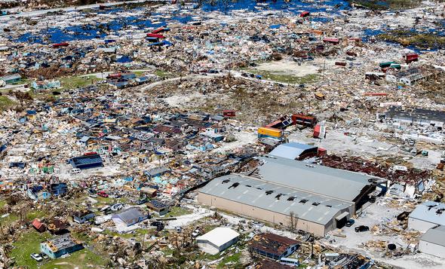

6. Second strongest Atlantic hurricane on record—Dorian—ravages The Bahamas

After hitting St. Thomas in the U.S. Virgin Islands as a category 1 hurricane on August 28 and causing $150 million in damage to the Caribbean islands, Hurricane Dorian rapidly intensified into a category 5 mega-hurricane that powered ashore on Great Abaco Island in The Bahamas on September 1, 2019 with sustained winds of 185 mph. This tied Dorian with the 1935 Florida Keys Labor Day Hurricane as the most powerful landfalling Atlantic hurricane (by wind speed) on record. Dorian was also the strongest hurricane ever recorded in the open Atlantic, outside of the Caribbean and Gulf of Mexico. The only stronger Atlantic hurricane on record was Allen of 1980, which had 190 mph winds in the Western Caribbean.

At landfall, Dorian was moving at just 5 mph, and portions of Dorian’s eyewall lashed Great Abaco and Grand Bahama islands with Category 5 winds for a total of 22 hours before the great hurricane finally weakened to Category 4 strength. Dorian’s extreme winds, storm surge of 20 – 25 feet, and rains of up to 3 ft (0.9 m) of rain combined to bring the Bahamas their most devastating natural disaster in history. A [November 15 report](https://www.iadb.org/en/damages-and-other-impacts-bahamas-hurricane-dorian-estimated-34-billion-report) from the Inter-American Development Bank put damage in The Bahamas from Dorian at $3.4 billion—over 25% of their $12 billion GDP, and their most expensive disaster in history. Insurance broker Aon put Dorian’s damages in excess of $9 billion, but this number may need to be adjusted downward, according to an email I received from Steve Bowen at Aon. Dorian killed 70 and left 300 people missing in The Bahamas, according to [reliefweb.com](https://reliefweb.int/report/bahamas/hurricane-dorian-situation-report-17-december-12-2019).

Dorian’s stall allowed the hurricane’s winds to upwell enough cool water to significantly weaken the storm, and the hurricane made landfall on September 6 at Cape Hatteras, North Carolina as a Category 1 hurricane with 90 mph winds and a minimum central pressure of 956 mb. Dorian killed ten people in the U.S., cost $1.4 billion, and spawned a political firestorm—Sharpiegate—after President Trump incorrectly tweeted on September 1 that Alabama would “most likely be hit (much) harder than anticipated.”

Dorian also hit Canada hard, making landfall in eastern Nova Scotia on September 7 as an extratropical cyclone with Category 2 winds of 100 mph and a pressure of 958 mb, making it the third strongest hurricane or ex-hurricane on record to hit Canada. Damage in Canada was [estimated](https://www.thetelegram.com/business/dorian-caused-more-than-100-million-damage-360542/) at $200 million.

Figure 7. Tropical Cyclone Idai as seen by the VIIRS instrument on the Suomi satellite on March 14, 2019. At the time, Idai was a high-end category 2 storm with 110 mph winds, and was nearing landfall near Beira, Mozambique. Credit: [NASA](https://www.facebook.com/NASAEarthData/photos/a.659464097451251/2286894138041564/?type=3&theater)

7. Tropical Cyclone Idai kills 964—the Southern Hemisphere's third deadliest tropical cyclone on record

In scenes reminiscent of Hurricane Katrina in New Orleans in 2005, Mozambique’s Tropical Cyclone Idai on March 14 left thousands of people marooned on rooftops in an “inland ocean” up to 30 miles wide that the great cyclone’s heavy rains and storm surge created. Idai made landfall as a Category 2 storm with 110 mph winds just north of Beira, Mozambique (population 530,000) near the time of high tide, driving a devastating storm surge into the city.

**8. Australia’s apocalyptic fire season**

Australia suffered its hottest and driest year on record in 2019, according to the [Australian Bureau of Meteorology](https://twitter.com/RARohde/status/1212363142434611200). The record heat and dryness created some of the most apocalyptic early-season fire activity ever witnessed in the country, with at least 21 people killed, 15 million acres burned, and 3500 structures destroyed. Shane Fitzsimmons, the Rural Fire Services commissioner for New South Wales, told the [Sydney Morning News](https://www.smh.com.au/national/nsw/extraordinary-2019-ends-with-deadliest-day-of-the-worst-fire-season-20191231-p53nw0.html) that 2019 was “absolutely” the worst fire season in the history of that southeastern state, which includes Sydney. Thousands of people had to flee to the beach to avoid incineration and be given supplies and evacuated by military ships and aircraft.

The fire season got off to an unusually early start, thanks to the southern spring (September-November) being the nation’s [driest on record](http://www.bom.gov.au/climate/current/month/aus/summary.shtml). Australia had its hottest day in recorded history on December 18, when daily highs averaged across the nation hit 40.9°C (105.6°F). That record was bettered by a full degree the next day, when the high temperatures averaged out at 41.9°C (107.4°F). A reading of 49.9°C (121.8°F) at Nullarbor on the 19th was the hottest temperature reliably measured on Earth in any December. With summer only one-third over, the fire situation is likely to grow even more dire in Australia.

The heat and dryness are partially due to an especially strong positive mode of the Indian Ocean Dipole (IOD), which brings dry, sinking air to Australia. Another natural cycle, the Southern Annual Mode (SAM), is also contributing to the heat and dryness in Australia. However, As noted by Bob Henson at Weather Underground [on December 19](https://www.wunderground.com/cat6/Roasted-Australia-Hottest-Days-Record-Continent), the heat is also consistent with what we’d expect due to human-caused climate change. The extreme heat and fires are causing political repercussions in a fossil fuel-rich nation known for its climate science-denying politicians.

The 2019 fires were not the deadliest, most destructive, or most widespread on record for Australia as a whole, though. The deadliest Australian fires occurred on [“Black Saturday,”](https://www.nma.gov.au/defining-moments/resources/black-saturday-bushfires) a catastrophic sequence of fires that ravaged the adjoining Victoria state starting on February 7, 2009, killing 173 people. The most widespread bushfire season in modern Australia history was 1974-75, when approximately 15% of the entire Australian continent (289 million acres) burned, according to the nation’s [Bureau of Statistics](https://www.abs.gov.au/Ausstats/abs@.nsf/0/6C98BB75496A5AD1CA2569DE00267E48). Heavy rains in the prior two years had led to unusually lush grasslands that dried out in the summer heat, allowing vast areas to burn.

9. Typhoon Hagibis: Japan’s second most expensive typhoon in history ($15 billion)

Japan suffered the second most expensive typhoon strike in its history in 2019 when Typhoon Hagibis roared ashore in the Nagano prefecture on October 12, 2019 as a category 2 storm with 100 mph winds. Hagibis tracked over the Tokyo metropolitan area and unleashed unprecedented rains and catastrophic flooding across much of Japan, killing 98 and causing over $15 billion in damage, making it Earth’s most expensive weather-related disaster of 2019. Hagibis came less than two months after the landfall of Typhoon Faxai, which also made landfall as a category 2 storm and tracked over Tokyo. Faxai did $7 billion in damage, making it Japan’s seventh most expensive typhoon on record.

According to inflation-adjusted damage estimates from Aon and EM-DAT, three of the top ten most damaging Japanese typhoons since 1950 have occurred since 2018. A fourth typhoon, Trami of 2018, with $4.6 billion in damage, just missed making the list:

Mireille, 1991, $19.1 billion

Hagibis, 2019, $15 billion

Jebi, 2018, $12.6 billion

Songda, 2004, $12.5 billion

Flo, 1990, $8.0 billion

Bart, 1999, $7.8 billion

Faxai, 2019, $7.0 billion

Vera, 1959, $5.3 billion (5098 deaths)

Sarah, 1986, $5.1 billion

Vicki, 1998, $4.8 billion

This list does not include the $10.2 billion flood disaster in southern Japan in July 2018, which was caused by the presence of a stationary seasonal frontal boundary enhanced by remnant moisture from Typhoon Prapiroon. Hurricane scientists agree that typhoons in the Northwest Pacific are reaching their maximum intensities at a more northerly latitude than they used to, which has increased the typhoon risk to Japan. In a 2019 review paper by 11 hurricane scientists, Tropical Cyclones and Climate Change Assessment: Part I. Detection and Attribution, nine of 11 authors concluded that the balance of evidence suggested that human-caused climate change contributed to the observed poleward migration of more intense typhoons.

In the same study, ten of 11 authors concluded that the balance of evidence suggests that there is a detectable increase in the average intensity globally of hurricane-strength tropical cyclones (including typhoons) since the early 1980s, and eight of 11 authors concluded that the balance of evidence suggests that human-caused climate change contributed to this increase in intensity.

Flooding in the Midwest in March 2019 compared with March 2018

Figure 10. On March 16, 2019, the Operational Land Imager (OLI) on Landsat 8 captured a false-color image that underscored the extent of the flooding on the Platte, Missouri, and Elkhorn Rivers. For comparison, the second image shows the same area in March 2018. Credit: NASA

10. Flooding from the wettest year in U.S. history costs over $15 billion

The contiguous U.S. had its wettest January through November period on record in 2019, and the period July 2018 - June 2019 was the wettest 12-month period in continental U.S. history. Almost every state had above-average precipitation in 2019, and the states of Michigan, Minnesota, North Dakota, South Dakota, and Wisconsin were record-wet. The record wetness led to over $15 billion in flood damage across the Midwest and Eastern U.S., according to insurance broker Aon. According to NOAA/NCEI, only one U.S. flood disaster since 1980 not associated with a hurricane has cost more—the great 1993 Midwest floods, at $37 billion (2019 dollars).

The March 12 – 14 “bomb cyclone” (Winter Storm Ulmer) that ripped through the central U.S. brought all-time record flooding to at least 40 river gauges. Strong southerly flow ahead of the storm brought warm, moist-laden air and heavy rains, which fell on frozen ground with a heavy snowpack. The rains melted massive amounts of water in snowpack, and the resulting runoff flowed over the frozen ground directly into the rivers. Great chunks of ice jammed rivers and levees gave way, leading to catastrophic flooding along and near the Missouri River, especially across eastern Nebraska and western Iowa. U.S. flood damage during March and April was estimated at $5 billion by Aon. Further heavy rains from April through July led to an additional $10 billion in flood damage across central and eastern portions of the U.S., and led to records for the longest span of flood conditions at several points along the Mississippi River.

Climate Change in 2019 – 2020

Amid the horror and uncertainty of a global health crisis it can be easy to forget that another worldwide disaster is unfolding, although much more slowly.

Global warming is happening, and its effects are being felt around the world. The only real debates are over how fast and how far the climate will change, and what society should do — the global-warming equivalents of lockdowns and social distancing — to slow or stop it and limit the damage.

So let’s take a closer look at one piece: what’s happening at the top of the world, the Arctic. It’s a good place to understand the science of climate change, and, it turns out, a critically important one to understand its effects.

Since the mid-1990s, the Arctic has been warming faster than any other region of the planet: currently, at least two and a half times as fast. (Last year, average air temperatures were about 3.5 degrees Fahrenheit, or 1.9 degrees Celsius, higher than the average from 1981-2010.)

In large part, the Arctic is warming the way the rest of the world warms, only up north the process has run amok.

As the concentration of carbon dioxide and other greenhouse gases increase in the atmosphere, so does the amount of heat they trap. But the source of that heat is sunlight striking the Earth, and the amount of heat radiated differs depending on the surface the sunlight hits. Just as a black car gets much hotter than a white car on a sunny day, darker parts of the planet absorb more sunlight, and in turn radiate more heat, than lighter parts.

The Central Arctic is all ocean — dark water that is covered, to a varying extent, by light ice. The ice absorbs only about 30 to 40 percent of the sunlight hitting it; the rest is reflected. Ocean, on the other hand, absorbs more than 90 percent.

As the Arctic warms more of the ice disappears, leaving more dark ocean to absorb more sunlight and radiate even more heat, causing even more loss of ice. It’s a vicious cycle that contributes to rapid warming in the region.

Is this happening at the South Pole as well? No, because while the Arctic is mostly water surrounded by land, Antarctica is the opposite, a huge land mass surrounded by ocean. Some of the ice that covers the continent is melting, but no dark ocean is being exposed. (That’s not to say that the continent isn’t losing ice: it is, mostly through calving of icebergs and melting of the undersides of ice shelves.)

In the Arctic, currents and winds flow out of the region and affect weather elsewhere.

Weakening of the high-altitude winds known as the polar jet stream can bring extra-frigid winter weather to North America and Europe. Cold snaps like these have occurred for a long time although, because of global warming, studies have found that they are not as cold as they used to be. But some scientists now say they think Arctic warming is causing the jet stream to wobble in ways that lead to more extreme weather year round, by creating zones of high-pressure air that can cause weather systems — the ones that bring extreme heat, for example — to stall.

Arctic warming may also be affecting climate over the longer term. As Greenland’s ice sheet melts, the fresh water it releases lowers the saltiness of the nearby ocean. These salinity changes may eventually have an effect on some of the large ocean currents that help determine long-term climate trends in parts of the world.

As climate researchers are fond of saying, what happens in the Arctic doesn’t stay in the Arctic.

Report 2: Google’s Environmental Impact Assessment

While millions of people tap into Google without considering the environment, a typical search generates about 7 grams of CO2. Boiling a kettle generates about 15 grams.

Google operates huge data centers around the world that consume a great deal of power. A report by Gartner, the industry analysts, said the global IT industry generated as much greenhouse gas as the world's airlines — about 2 percent of global CO2 emissions.

Though Google says it is in the forefront of green computing, its search engine generates high levels of CO2 because of the way it operates. When you type in a Google search for, say, "energy saving tips," your request doesn't go to just one server. It goes to several competing against each other. It may even be sent to servers thousands of miles apart. Google's infrastructure sends you data from whichever produces the answer fastest. The system minimizes delays but raises energy consumption.

• [Data Centers](https://sustainability.google/reports/environmental-report-2019/#data-centers)

Google’s data centers are the heart of our company, powering products like Search, Gmail, and YouTube for billions of people around the world, 24x7. We own and operate 15 data centers13 on four continents and continue to add new sites to better serve our customers. Each data center is a large campus where the vast majority of our facilities, servers, networking equipment, and cooling systems are designed from the ground up for maximum efficiency and minimal environmental impact.

In 2018, the average annual power usage effectiveness (PUE)16 for our global fleet of data centers was 1.11, compared with the industry average of 1.6717— meaning that Google data centers use about six times less overhead energy (11%) for every unit of IT equipment energy (see Figure 3). We aim to maintain or improve our quarterly PUE at each Google data center, year over year. Our fleet-wide PUE has stayed at or below 1.12 since 2013 (see Figure 4). Generating electricity requires water, so the less energy we use to power our data centers, the less water we use as well. The source of energy matters too: Wind and solar energy require considerably less water to produce than do coal and nuclear energy. In 2018, matching our data center electricity consumption with renewable energy reduced embedded water use by 88% on average compared with buying grid power.

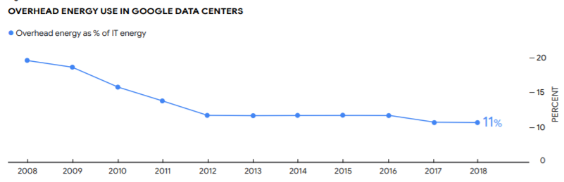

• [Carbon-Free Energy](https://sustainability.google/reports/environmental-report-2019/#renewable-energy)

Running our business requires us to use a lot of electricity to power our data centers, offices, and other infrastructure. And combating climate change requires the world to transition to a clean energy economy. So we’ve made it a top priority to become more energy efficient and to match every unit of energy we consume at our facilities around the world with an equivalent unit of energy from renewable sources, such as wind and solar. Our support for clean energy goes hand in hand with reducing our carbon footprint. By improving the efficiency of our operations and buying both renewable power and high-quality carbon offsets, we’ve been carbon neutral since 2007

We’re the first company of our size to achieve 100% renewable energy two years running.28 While we’re still drawing power from the grid, some of which is from fossil fuel resources, we’re purchasing enough renewable energy to match every MWh of electricity our data center and office operations consume.

Our long-term goal is to source carbon-free energy to match our electricity consumption in all places, at all times. This means realizing a future where each Google facility is always matched—around the clock—with local carbon-free power. Our ultimate vision is to create a world where everyone has access to clean energy; this includes not only Google, but our suppliers and their communities.

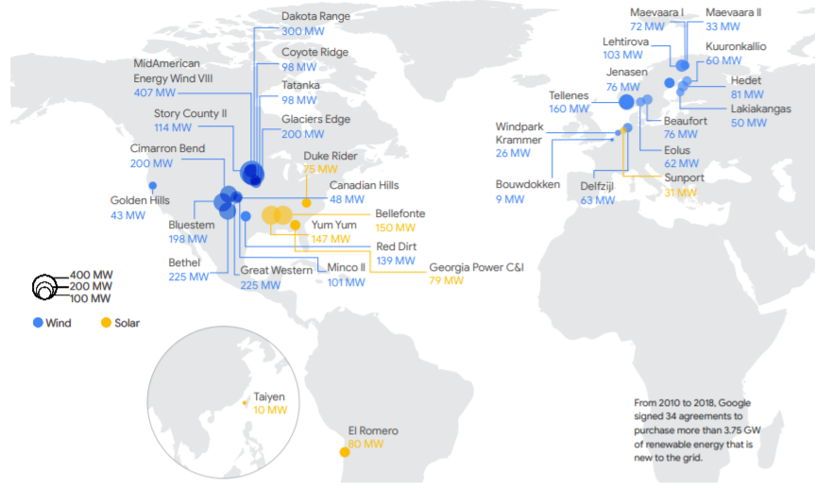

Reaching 100% renewable energy

We achieved our 100% renewable energy target much faster and at much greater scale than we thought possible when we set this goal seven years ago. We met it primarily by buying renewable electricity directly from new wind and solar farms via long-term power purchase agreements (PPAs) on the grids where we have operations, as well as by buying renewable power through utilities via renewable energy purchasing models that we helped create. In addition, a portion of our utility energy purchases include renewable sources as part of the utility’s grid mix.29 With our PPAs, we’re purchasing physical renewable energy, which includes the electrons bundled with renewable energy certificates (RECs).

• [Workplaces](https://sustainability.google/reports/environmental-report-2019/#workplaces)

Americans spend roughly 90% of their time indoors, and much of that time is spent at work.42 At Google, just as we focus on people when it comes to designing our products, we also focus on people when creating healthy and sustainable workplaces—from our Bay Area headquarters to our offices in more than 150 cities spanning over 50 countries around the world. To do so, we look for innovative ideas that deliver measurable results and can be implemented at scale.

We start by applying industry-leading green building standards wherever possible. Our ongoing goal is to pursue third-party green or healthy-building certifications for our office projects, such as LEED, WELL Building Standard, and Living Building Challenge. By the end of 2018, over 1.2 million square meters (13 million square feet) of Google office facilities had achieved LEED certification, with 28% of our LEED-certified square footage achieving a Platinum rating and 57% a Gold rating

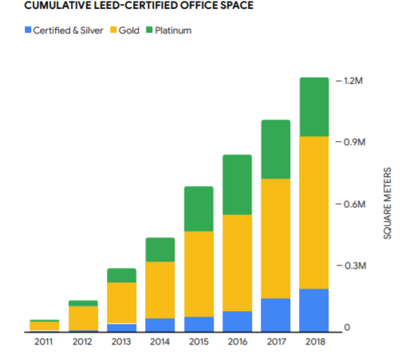

• [Devices and Services](https://sustainability.google/reports/environmental-report-2019/#hardware)

At Google, we strive to build sustainability into everything we do. And, now that our business includes building consumer hardware, our commitment remains the same. Our ambition is that every product we build will leave people, the planet, and our communities better than we found them. We’re at the start of a journey of reimagining how even better devices and consumer hardware experiences are created.

Consumer devices

Over the past few years, we’ve been steadily growing our family of great consumer hardware products. We see tremendous potential for devices to be helpful, make your life easier, and get better over time by combining the best of Google’s AI, software, and hardware. This is reflected in our latest generation of hardware products like Pixel 3 phones and the Google Nest Hub smart display. Creating beautiful products that people rely on every day is a journey that we’re investing in for the long run, and one we want to do in a sustainable way.

In 2018, we launched a suite of new products, including the Pixel 3 and Pixel 3 XL phones, Google Pixel Slate, Google Nest Hub, Google Clips, Google Nest Hello Doorbell, Google Nest Temperature Sensor, Nest x Yale Lock, Titan Security Key, and Chromecast. Other products we offer include Google Home, Google Home Max, Google Home Mini, and Google Pixelbook. We hold ourselves to the highest environmental standards and strive to ensure that Google products are designed, manufactured, and disposed of in a sustainable way. This applies to how we think about materials, manufacturing processes, energy efficiency, and packaging.

Report 3: History of Sustainable Development

The concept of sustainable development formed the basis of the United Nations Conference on Environment and Development held in Rio de Janeiro in 1992. The summit marked the first international attempt to draw up action plans and strategies for moving towards a more sustainable pattern of development. It was attended by over 100 Heads of State and representatives from 178 national governments. The Summit was also attended by representatives from a range of other organisations representing civil society. Sustainable development was the solution to the problems of environmental degradation discussed by the Brundtland Commission in the 1987 report Our Common Future.

The remit of the Brundtland Report was to investigate the numerous concerns that had been raised in previous decades, namely, that human activity was having severe and negative impacts on the planet, and that patterns of growth and development would be unsustainable if they continued unchecked. Key works that highlighted this thinking included Rachel Carson's Silent Spring (1962), Garret Hardin's Tragedy of the Commons (1968), the Blueprint for Survival by the Ecologist magazine (1972) and the Club of Rome's Limits to Growth report (1972).

The concept of sustainable development received its first major international recognition in 1972 at the UN Conference on the Human Environment held in Stockholm. The term was not referred to explicitly, but nevertheless the international community agreed to the notion - now fundamental to sustainable development - that both development and the environment, hitherto addressed as separate issues, could be managed in a mutually beneficial way.

The term was popularised 15 years later in Our Common Future, the report of the World Commission on Environment and Development, which included what is deemed the 'classic' definition of sustainable development: "development which meets the needs of the present without compromising the ability of future generations to meet their own needs".

It was not until the Rio Summit, however, that major world leaders recognised sustainable development as the major challenge it remains today.

More recently, the World Summit on Sustainable Development was held in Johannesburg in 2002, attended by 191 national governments, UN agencies, multilateral financial institutions and other major groups to assess progress since Rio. The Johannesburg Summit delivered three key outcomes: a political declaration, the Johannesburg Plan of Implementation, and a range of partnership initiatives. Key commitments included those on sustainable consumption and production, water and sanitation, and energy.

Sustainability goals of UN

The Sustainable Development Goals (SDGs), also known as the Global Goals, were adopted by all United Nations Member States in 2015 as a universal call to action to end poverty, protect the planet and ensure that all people enjoy peace and prosperity by 2030.

The 17 SDGs are integrated—that is, they recognize that action in one area will affect outcomes in others, and that development must balance social, economic and environmental sustainability.

Through the pledge to Leave No One Behind, countries have committed to fast-track progress for those furthest behind first. That is why the SDGs are designed to bring the world to several life-changing ‘zeros’, including zero poverty, hunger, AIDS and discrimination against women and girls.

The newly implemented 2030 Agenda for Sustainable Development holds a deep promise for persons with disabilities everywhere.

The year 2016 marks the first year of the implementation of the SDGs. At this critical point, #Envision2030 will work to promote the mainstreaming of disability and the implementation of the SDGs throughout its 15-year lifespan with objectives to:

• Raise awareness of the 2030 Agenda and the achievement of the SDGs for persons with disabilities;

• Promote an active dialogue among stakeholders on the SDGs with a view to create a better world for persons with disabilities; and

• Establish an ongoing live web resource on each SDG and disability.

The SDGs coincided with another historic agreement reached in 2015 at the COP21 Paris Climate Conference. Together with the Sendai Framework for Disaster Risk Reduction, signed in Japan in March 2015, these agreements provide a set of common standards and achievable targets to reduce carbon emissions, manage the risks of climate change and natural disasters, and to build back better after a crisis.

The SDGs are unique in that they cover issues that affect us all. They reaffirm our international commitment to end poverty, permanently, everywhere. They are ambitious in making sure no one is left behind. More importantly, they involve us all to build a more sustainable, safer, more prosperous planet for all humanity.

The 17 sustainable development goals (SDGs) to transform our world:

GOAL 1: No Poverty: End poverty in all its forms everywhere

GOAL 2: Zero Hunger: "End hunger, achieve food security and improved nutrition, and promote sustainable agriculture".

GOAL 3: Good Health and Well-being: "Ensure healthy lives and promote well-being for all at all ages".

GOAL 4: Quality Education: "Ensure inclusive and equitable quality education and promote lifelong learning opportunities for all".

GOAL 5: Gender Equality: "Achieve gender equality and empower all women and girls".

GOAL 6: Clean Water and Sanitation: "Ensure availability and sustainable management of water and sanitation for all".

GOAL 7: Affordable and Clean Energy: "Ensure access to affordable, reliable, sustainable and modern energy for all".

GOAL 8: Decent Work and Economic Growth: "Promote sustained, inclusive and sustainable economic growth, full and productive employment and decent work for all".

GOAL 9: Industry, Innovation and Infrastructure: "Build resilient infrastructure, promote inclusive and sustainable industrialization, and foster innovation".

GOAL 10: Reduced Inequality: "Reduce income inequality within and among countries".

GOAL 11: Sustainable Cities and Communities: "Make cities and human settlements inclusive, safe, resilient, and sustainable".

GOAL 12: Responsible Consumption and Production: "Ensure sustainable consumption and production patterns".

GOAL 13: Climate Action: "Take urgent action to combat climate change and its impacts by regulating emissions and promoting developments in renewable energy".

GOAL 14: Life Below Water: "Conserve and sustainably use the oceans, seas and marine resources for sustainable development".

GOAL 15: Life on Land: "Protect, restore and promote sustainable use of terrestrial ecosystems, sustainably manage forests, combat desertification, and halt and reverse land degradation and halt biodiversity loss".

GOAL 16: Peace and Justice Strong Institutions: "Promote peaceful and inclusive societies for sustainable development, provide access to justice for all and build effective, accountable and inclusive institutions at all levels".

GOAL 17: Partnerships to achieve the Goal: "Strengthen the means of implementation and revitalize the global partnership for sustainable development"

To achieve sustainable development, three sectors need to come together. The economic, socio-political, and environmental sectors are all critically important and interdependent. Progress will require multidisciplinary and trans-disciplinary research across all three sectors. This proves difficult when major governments fail to support it.

According to the UN, the target is to reach the community farthest behind. Commitments should be transformed into effective actions requiring a correct perception of target populations. However, numerical and non-numerical data or information must address all vulnerable groups such as children, elderly folks, persons with disabilities, refugees, indigenous peoples, migrants, and internally-displaced persons.

Implementation of the SDGs started worldwide in 2016. This process can also be called "Localizing the SDGs". Individual people, universities, governments, institutions and organizations of all kinds work are working separately but one or more goals at the same time. Individual governments must translate the goals into national legislation, develop a plan of action, and establish their own budget. However, at the same time, they must be open to and actively searching for partners. Coordination at the international level is crucial, making partnerships valuable. The SDGs note that countries with less access to financial resources need partnerships with more well-to-do countries.